No Replication Without Process Documentation: An Assessment of Management Strategy Evaluations

#### Jonathan W. Cummings1, Amanda Hart1, Gavin Fay1

1School for Marine Science and Technology, University of Massachusetts – Dartmouth

# Abstract

The aim and vision for fisheries management that comes from management strategy evaluation and adaptive management is a noble and aspirational vision. We review MSE documentation in the published literature to appraise the achievement of this vision, finding that reality doesn’t fully reflect this vision. The steps taken to complete the MSE process often are not documented. Scientists often filled the role of fishery stakeholders, seemingly selecting the objectives and alternatives to evaluate in most MSEs. Facilitators and decision analysts – participants focused on the decision making process – were rarely participants in MSE processes. Conservation, Economic, and Yield focused objectives were commonly considered in MSE processes, while broader social objectives were rarely considered. The picture painted by MSE documentation is primarily one of scientist driven simulation studies rather than management driven decision processes, with limited process documentation.

# Introduction

The calls for fisheries management to utilize management strategy evaluation and adaptive management have been both aspirational and estimable in their aim and vision. For example, management strategy evaluation (MSE) is “widely considered to be the most appropriate way to evaluate the trade‐offs achieved by alternative management strategies and to assess the consequences of uncertainty for achieving management goals” (Punt et al. 2014). The positive aspects of MSE that have been listed include that it is “A tool that scientists and managers can use to simulate the workings of a fisheries system and allow them to test whether potential harvest strategies—or management procedures— can achieve pre-agreed management objectives.”(Nickson 2016), that it “can be used to identify a ‘best’ management strategy among a set of candidate strategies” (Punt 2014) and “MSE has the advantage of being able to reveal the trade-offs among a range of possible management decisions, and should assist our Commissioners in determining whether the objectives should be weighted differently. Specifically, to provide the information on which to base a rational decision, given objectives, preferences, and attitudes to risk.” (Commission 2017). Based on these descriptions MSE is a compelling tool to support and improve fisheries management decisions.

In terms of the MSE process, it is described as being “at the interface between science and policy.” (Punt 2014) and being an “Undertaking [that] requires scientists, managers, and stakeholders to be involved throughout the process.” (Commission 2017) The International Pacific Halibut Commission (2017) also states, “While the scientists do the modelling, managers must offer extensive input. Because of the many steps and the iterative process, communication among parties is critical for achieving buy-in on the results of the management strategy evaluation.”

Adaptive management developed in fisheries management to improve the achievement of objectives through time, when learning can aid achieving those objectives (Walters 1986). For example, the Millennium Ecosystem Assessment (“Ecosystems and Human Well-Being” 2005) defines adaptive management as “A systematic process for continually improving management policies and practices by learning from the outcomes of previously employed policies and practices. In active adaptive management, management is treated as a deliberate experiment for purposes of learning.” We contend that scientific publication is essentially a process intended to support adaptive management, in that researchers gain knowledge from the decisions made and outcomes produced by previous work to inform their decisions. In the case of fisheries management, are scientific publications of management strategy evaluations supporting adaptive management?

### Objectives

Our overall objective is to determine the extent that MSE documentation can support learning within the MSE practitioner community? Given that scientific publication is the primary means of communicating the results of MSE, we review the scientific literature to assess the extent to which the process and aims of MSE, and adaptive management are being achieved and supported by the scientific literature. To assess this, we determine how MSEs utilize standard components of decision making processes. We use the structured decision making (SDM) process (USGS 2019) – the decision making framework in which adaptive management occurs – as our framework for evaluation. Using this framework, we review published MSEs to:

* Determine what questions MSE processes are addressing
* Identify the objectives and alternatives considered in MSE
* Determine the prevalence of explicit documentation and use of decision making steps in the MSE process, and
* Identify participants in MSE processes.

We also conduct a focused analysis of MSE processes that address the influence of climate change on fisheries management, highlighting unique aspects of MSE processes that model climate change as a driver of system status.

# Methods

## Finding and Sampling the MSE Literature

We conducted our search for MSEs in the SCI-EXPANDED index from Web of Science, searching for “management strategy evaluation” by topic across all years on January 8th, 2019. This search returned 253 results. We reviewed a random sample of 30 articles that document a MSE, removing articles that were reviews, meta-analyses, or simply cited other MSE articles from our sample. Of the 253 articles, 11 included climate change as a driver of fishery status, and after removing other articles we estimate 110-160 articles document a MSE.

|  |  |
| --- | --- |
| MSE type | Count |
| Published | 150 |
| Random Sample | 30 |
| Climate Change | 11 |

## Reviewing MSE documentation

We used the structured decision making framework (Conroy and Peterson 2013; Gregory et al. 2012) as our framework for evaluating management strategy evaluation documents (Figure 1). The structured decision making process is composed of the six process stages: problem definition, objective elicitation, alternative development, consequence prediction, trade-off analysis, and decision implementation.

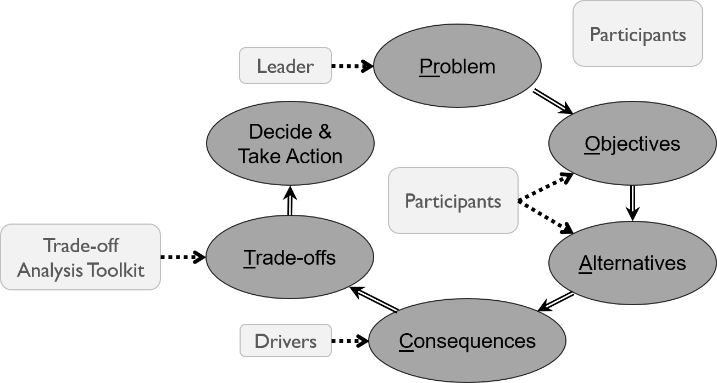

Figure 1: Review framework - structured decision making process

We present the review methodology and results in four groups: consequences - which focuses on what was considered during the prediction stage, objectives - which focuses on what categories of objectives were considered, stages - which focuses on whether and how the stages of the process were completed, and participants - which focuses on how participation in the process was structured. These results were entered into a relational database for storage and evaluation, and is available via our shiny application (<https://jonathancummings.shinyapps.io/MSEreview/>).

The consequence group addresses what question the MSE was designed to address, and how it was addressed. We report the drivers included as the primary factors influencing the predictions produced by the MSE model, listing each driver a MSE included. We also report how the consequence predictions were made, with possible values of simulation modeling, dynamic programming, expert elicitation, mental models, and unknown.

In the objectives group we address what the concerns, or goals of the MSE were. We record each objective considered, and report the type and category of objectives included in each MSE. Natural resource management problems typically include four types of objectives: conservation, resource use, i.e., yield in the fisheries context, economic, and social objectives (Runge, Grand, and Mitchell 2013). We sort objectives into four types: strategic objectives - which are concerned with the overall mission of the system in which the decision evaluated by the MSE falls, process objectives - which are concerned with how the management decision addressed by the MSE would be made, fundamental objectives - which address the goals of the management decision, and means objectives - which address means to achieving the fundamental objectives of the management decision.

In the stages group we address how the MSE stages were completed. We report whether the stages of the structured decision making framework were explicitly completed and documented. We also report whether the MSE results were adopted in subsequent management.

In the participant group we address how participation in the MSE process was structured and who participated. We report who lead the MSE, who participated in it, and if the roles of participants were established and documented. In many cases the process used to elicit objectives and alternatives was not explicit. In these cases, we used what information was provided to glean who participated in the production of those components of the MSE. We record and report who those participants were, referring to them as subjective participants in the objectives or alternatives process. In other cases where there was not enough information to glean who participated we report the participants as unknown.

We collected additional information about the MSEs we reviewed beyond what is reported here. For a full description of the information recorded in the relational database see the supplemental information (supplement), and for the full data set and results see our shiny application (<https://jonathancummings.shinyapps.io/MSEreview/>).

# Results

### What questions and management objectives do MSEs address?

We found that uncertainty was the main driver of the system state included in management strategy evaluations, with uncertainty included in 21 of the 30 evaluations we reviewed (Table 1). In addition to uncertainty about the system model itself, monitoring methodology was the most prevalent driver in MSE models, but a variety of drivers were considered across the random sample of MSEs.

Table 1: Drivers included in management strategy evaluations

|  |  |  |
| --- | --- | --- |
| Driver | Percent | Frequency |
| Uncertainty | 70 | 21 |
| Monitoring methodology | 20 | 6 |
| Spatial structure | 13 | 4 |
| Allowable catch adjustment | 10 | 3 |
| Environmental conditions | 10 | 3 |
| Fishing behavior | 10 | 3 |
| Implementation uncertainty | 10 | 3 |
| Ecosystem based management | 7 | 2 |
| Species interactions | 7 | 2 |
| Climate change | 3 | 1 |
| Landing regulations | 3 | 1 |
| Management timeline | 3 | 1 |
| Migration | 3 | 1 |
| Multiple sectors in fishery | 3 | 1 |
| Stock status | 3 | 1 |

Conservation objectives were present in nearly all of the MSEs we reviewed (Table 2). Yield and economic objectives were present in about three quarters of the MSEs, while social objectives were only included in 2 of the MSEs.

Table 2: Consideration of objective categories in management strategy evaluation

|  |  |  |
| --- | --- | --- |
| Objective category | Percent | Frequency |
| Conservation | 93 | 28 |
| Economic | 73 | 22 |
| Yield | 73 | 22 |
| Social | 7 | 2 |
| Utility | 3 | 1 |

No strategic or process objectives were documented in the MSEs we reviewed. There were roughly the same number of fundamental and means included in the MSEs (Table 3).

Table 3: Objective Types

|  |  |  |  |
| --- | --- | --- | --- |
| Type | Number | Percent | Per MSE |
| Fundamental | 94 | 53 | 3.13 |
| Means | 85 | 47 | 2.83 |

## Are structured decision making steps explicit in MSEs?

The majority of MSEs did not explicitly document how the stages of the MSE process – defined using the SDM framework – were completed (Table 4). The consequence prediction stage – which is the primary focus of MSE publication – was always addressed. Apart from the consequence stage, the most documented stage was the alternative stage with 6 MSEs documenting this stage of the process. Three of the 30 MSEs explicitly documented a trade-off analysis and 2 of the 30 documented a management decision. One MSE documented that the results of the MSE were adopted.

Table 4: Prevalence of explicit documentation of stages in the MSE process

|  |  |  |
| --- | --- | --- |
| Explicit | Number | Percent |
| Process | 5 | 17 |
| Problem | 5 | 17 |
| Objectives | 5 | 17 |
| Alternatives | 6 | 20 |
| Tradeoffs | 3 | 10 |
| Decision | 2 | 7 |
| Results adopted | 1 | 3 |

### Who is involved in MSEs?

MSEs were rarely explicit about the roles participants played in MSE processes, as only one MSE documented participant roles (Table 5). None of the MSEs noted whether public meetings were held in which the public could participate in the MSE process.

Table 5: Prevalence of explicit roles for MSE participants and meetings that were open to the public during the MSE process

|  |  |  |
| --- | --- | --- |
| Explicit | Number | Percent |
| Roles | 1 | 3 |
| Open meetings | 0 | 0 |

The primary participants and leaders of the MSE processes were scientists, while some MSE process were led by governments and management agencies (Figure 2). Scientist led 73 percent of the MSE processes, with another 23 percent lacking documentation that made the leader of the process clear.

Scientists were participants in nearly all of the reviewed MSE processes. Other stakeholders in MSE processes were less frequent participants. Members of the fishery participated in 30 percent, management and government representatives in 23 percent, representatives of independent institutions in 7 percent, and the members of the public in 3 percent of reviewed MSEs. Decision makers – those responsible for selecting the management plan to implement – were participants in 13 percent of MSEs. Experts, a possible source of data or predictions, participated in 3 percent of the MSEs reviewed. Participants involved to the assist the MSE process itself, i.e., facilitators and analysts, participated in 10 and 3 percent of MSE processes respectively.

Objectives and alternatives were elicited from a variety of participants. About 10 percent of the objectives and alternatives explicitly were produced by stakeholders in the fisheries, coming from management, government, or fishery sources. In most cases the source of the objectives and alternatives was not explicit. In those cases, scientists selected these components most frequently, while in some cases the source was unknown.

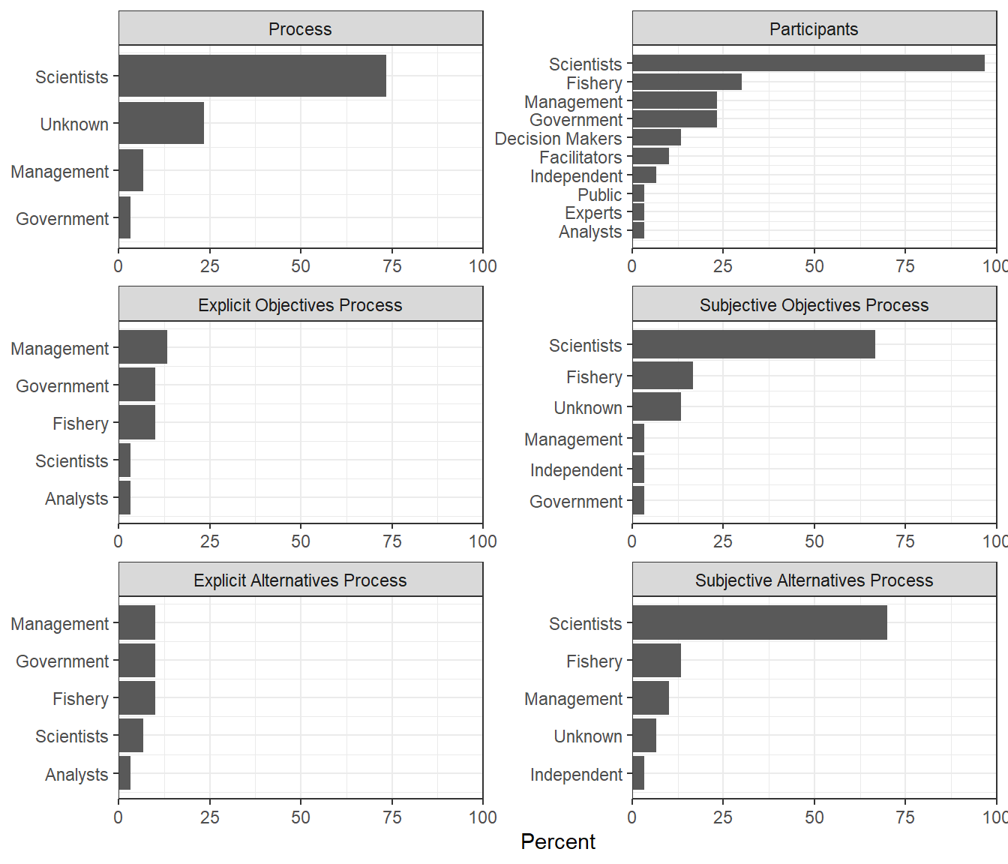

Figure 2: Who guided, participated in, or provided input during the specified steps of the MSE process

|  |  |  |  |  |  |  |  |  |  |  |  |  |  |  |  |  |  |  |  |  |  |  |  |  |  |  |  |  |  |  |  |  |  |  |  |  |  |  |  |  |  |  |  |  |  |  |  |  |  |  |  |  |  |  |  |  |  |  |  |  |  |  |  |  |  |  |  |  |  |  |  |  |  |  |  |  |  |  |  |  |  |  |  |  |  |  |  |  |  |  |
| --- | --- | --- | --- | --- | --- | --- | --- | --- | --- | --- | --- | --- | --- | --- | --- | --- | --- | --- | --- | --- | --- | --- | --- | --- | --- | --- | --- | --- | --- | --- | --- | --- | --- | --- | --- | --- | --- | --- | --- | --- | --- | --- | --- | --- | --- | --- | --- | --- | --- | --- | --- | --- | --- | --- | --- | --- | --- | --- | --- | --- | --- | --- | --- | --- | --- | --- | --- | --- | --- | --- | --- | --- | --- | --- | --- | --- | --- | --- | --- | --- | --- | --- | --- | --- | --- | --- | --- | --- | --- | --- |
| Climate Change in MSE Fisheries management has mostly focused on fishing impacts with ecosystem status viewed as a background constant. The increasing rate of climate change is changing this dynamic, bringing ecosystem status to the forefront of fisheries management.  We review published MSEs including climate change as a driver against the stages in a SDM process to: Highlight unique aspects of MSEs that model climate change as a driver to help inform fisheries management  We filtered the original set of MSE by searching for the term “climate change” within the set. We found that, as of the end of December 2018, 11 MSEs included climate change as a driver. We reviewed the climate change MSEs using the same methodology described above. These MSEs have been concentrated in North America and Australia (Figure 3).    Figure 3: Map of MSE study locations.  Uncertainty and monitoring methodology were also included in some of the climate change MSEs (Table 6), but not as often. Other biological drivers were also included in some of the climate change MSEs. Overall climate change MSEs considered fewer drivers on average, 1.64, than the random sample of MSEs, which included 1.87.  Table 6: Drivers included in climate change management strategy evaluations   |  |  |  | | --- | --- | --- | | Driver | Percent | Frequency | | Climate change | 100 | 11 | | Uncertainty | 18 | 2 | | Environmental conditions | 9 | 1 | | Habitat change | 9 | 1 | | Migration | 9 | 1 | | Monitoring methodology | 9 | 1 | | Spatial structure | 9 | 1 |   More objectives were considered per MSE in the random sample of MSEs than in the climate change MSEs (Table 7). Climate change MSEs were less likely to consider economic and social objectives than the random sample (Table 8).  Table 7: Number of objectives considered per management strategy evaluation   |  |  | | --- | --- | | Analysis | Per MSE | | Random Sample | 6.0 | | Climate Change | 4.1 |   Table 8: Objective categories considered in management strategy evaluations   |  |  |  |  | | --- | --- | --- | --- | | Analysis | Objective category | Percent | Frequency | | Random sample | Conservation | 93 | 28 | | Climate change | Conservation | 91 | 10 | | Random sample | Economic | 73 | 22 | | Climate change | Economic | 55 | 6 | | Random sample | Social | 7 | 2 | | Random sample | Utility | 3 | 1 | | Random sample | Yield | 73 | 22 | | Climate change | Yield | 82 | 9 |   Climate change MSEs were more likely to explicitly document the alternative elicitation and trade-off analysis stages, but otherwise were less likely to document stages in the decision process.  Table 9: Prevalence of explicit documentation of stages in climate change MSE processes   |  |  |  | | --- | --- | --- | | Explicit | Number | Percent | | Process | 1 | 9 | | Problem | 1 | 9 | | Objectives | 1 | 9 | | Alternatives | 3 | 27 | | Tradeoffs | 3 | 27 | | Decision | 0 | 0 | | Results adopted | 0 | 0 |   Including climate change in a MSE appears to reduce the complexity of other stages in the MSE process. On average climate change MSEs consider fewer drivers, consider fewer and less diverse objectives, and explicitly document fewer stages of the MSE process. If the MSE process is time or effort limited, the inclusion of climate change may utilize time and effort that in other cases was invested elsewhere in the MSE process. |

# Discussion

The primary picture painted by MSE documentation is one of scientist driven simulation studies rather than management driven decision processes. While documentation about the modeling conducted in a MSE was explicit, documentation about the MSE process itself was often limited.

Management strategy evaluations typically do assess the consequences of uncertainty for achieving management goals, but other factors influencing the consequences of management strategies get more sporadic treatment. Data limitation is a frequent concern in fisheries management. Next to accounting for uncertainty, accessing the influence of monitoring methodology was the most prevalent driver included in MSEs. Further inclusion of this driver, and additional use of value of information analyses could expand the use of MSE as a tool to design cost-effective fisheries monitoring plans. While discussions of fisheries research and management seem to be moving toward ecosystem effects, spatial models, and multiple species models, these characteristics were rarely considered in the set of MSEs we reviewed.

Managing natural resources entails achieving the objectives of people interacting with a natural resource, so decision processes are likely to produce more desirable results when they include peoples’ objectives. These objectives are likely to include conservation, yield, economic, and social concerns, however the MSEs we reviewed don’t cover all categories of objectives, as yield and economic objectives were not included in about one quarter of MSEs, and social objectives were absent from all but 2 of the 30 evaluations. While we are unable to know the cause for this with more explicit documentation of MSE processes, our results may provide some clues.

Scientists led, and participated in most of the MSEs, while decision-makers, decision making institutions, and stakeholders were relatively infrequent leaders and participants in the process. The lack of participation by stakeholders may result in less frequent inclusion of social objectives. Another factor may be that MSE models are likely constructed mainly by ecosystem modelers, who are likely to be more comfortable modeling the consequences of conservation and yield objectives than economic or social objectives. Given that scientists seem to be providing the objectives in many MSE processes, they may be selecting objectives that they are more comfortable evaluating. There also appears to be some degree of borrowing occurring in which scientists use a set of generic fishery objectives when conducting a MSE. Perhaps because there were few social objectives included in these MSE, there was little inclusion of experts to aid in the prediction of consequences, or consequence prediction techniques other than simulation modeling.

Participants that would be likely to expand the set of objectives considered in a MSE rarely participated in the MSEs we reviewed. That is, facilitators and decision analysts were rarely participants in MSE processes. The inclusion of facilitators in decision processes aid information gain and conflict resolution, increase trust between participants, and lead to more beneficial environmental and social outcomes (Vente et al. 2016). Facilitators and decision analysts also aid decision processes by helping to diagnose the problem, which can result in selecting more appropriate analysis techniques for the problem type. Finally, the additional structure and focus on the decision process would likely result in more explicit documentation when facilitators and decision analysts participate in MSE, as resulted in some of the MSEs reviewed here (Williams, Little, and Begg 2011; Smith et al. 2013; Kolody et al. 2008).

The relative dearth of explicit documentation we found in our review of MSE publications may hinder learning by MSE practitioners. While the modeling was clearly documented, the MSE process steps were often inexplicit. Without explicit documentation it is unclear why the analysis was structured as it was, why a particular set of drivers was selected, and why a set of objectives or alternatives were chosen. Perhaps the most crucial stage to enable understanding a replication of a decision resulting from a MSE is a clear presentation of how trade-offs between the multiple objectives were evaluated, and what the optimal or chosen alternative was that resulted from the MSE process. Different decision makers can rationally look at the same prediction of consequences and select a different preferred alternative if they treat the importance of the objectives differently. Therefore, MSE documentation often is not supporting replication or learning due to the frequent absence of trade-off and decision documentation.

The MSE process may be aided by utilizing the techniques from the structured decision making approach to decision analysis (Cummings, in prep). Utilizing the structured decision making approach eases the documentation process by breaking decision making into more discrete stages. There may be practical considerations, such as time or budgetary constraints that limit how complex the stages of a MSE are, and the degree of documentation that occurs. Where the expertise and budget are available, the use of facilitators and scribes may aid in addressing and documenting MSE processes.

### Explore and expand upon this review

To aid future learning from the MSEs that have been conducted to date we produced a shiny application (Chang et al. 2018) that enables interactive results to accompany this article and entry of additional MSE information (<https://jonathancummings.shinyapps.io/MSEreview/>). We hope that as MSE are conducted in the future they are entered here so that MSE practitioners can learn from each other.

# References

Chang, Winston, Joe Cheng, JJ Allaire, Yihui Xie, and Jonathan McPherson. 2018. *Shiny: Web Application Framework for R*. <https://CRAN.R-project.org/package=shiny>.

Commission, International Pacific Halibut. 2017. “Management Strategy Evaluation.” <https://iphc.int/management/science-and-research/management-strategy-evaluation>.

Conroy, Michael J, and James T Peterson. 2013. *Decision Making in Natural Resource Management: A Structured, Adaptive Approach*. John Wiley & Sons.

“Ecosystems and Human Well-Being.” 2005. Millennium Ecosystem Assessment.

Gregory, Robin, Lee Failing, Michael Harstone, Graham Long, Tim McDaniels, and Dan Ohlson. 2012. *Structured Decision Making: A Practical Guide to Environmental Management Choices*. John Wiley & Sons.

Kolody, D, T Polacheck, M Basson, and C Davies. 2008. “Salvaged Pearls: Lessons Learned from a Floundering Attempt to Develop a Management Procedure for Southern Bluefin Tuna.” *Fisheries Research* 94 (3). Elsevier: 339–50.

Nickson, Amanda. 2016. “Management Strategy Evaluation for Fisheries Informing the Selection of Harvest Strategies.” <https://www.pewtrusts.org/-/media/assets/2019/07/harvest-strategies/hs_mse_update.pdf>.

Punt, Andre E. 2014. “Management Strategy Evaluation.” <http://puntlab.washington.edu/management-strategy-evaluation/>.

Punt, Andre E, Doug S Butterworth, Carryn L de Moor, Jose A A De Oliveira, and Malcolm Haddon. 2014. “Management Strategy Evaluation: Best Practices.” *Fish and Fisheries*.

Runge, M.C., J.B. Grand, and M.S. Mitchell. 2013. “Structured Decision Making.” In *Wildlife Management and Conservation: Contemporary Principles and Practices*, edited by Paul R Krausman, James W Cain III, and James W Cain, 51–72. John Hopkins University Press.

Smith, David R, Conor P McGowan, Jonathan P Daily, James D Nichols, John A Sweka, and James E Lyons. 2013. “Evaluating a Multispecies Adaptive Management Framework: Must Uncertainty Impede Effective Decision-Making?” *Journal of Applied Ecology* 50 (6). Wiley Online Library: 1431–40.

USGS. 2019. *Structured Decision Making*. <https://www.usgs.gov/centers/pwrc/science/structured-decision-making>.

Vente, J. De, M. S. Reed, L. C. Stringer, S. Valente, and J. Newig. 2016. “How Does the Context and Design of Participatory Decision Making Processes Affect Their Outcomes? Evidence from Sustainable Land Management in Global Drylands.” *Ecology and Society 21 (2):24*. doi:[http://dx.doi.org/10.5751/ES-08053-210224](https://doi.org/http://dx.doi.org/10.5751/ES-08053-210224).

Walters, C.J. 1986. *Adaptive Management of Renewable Resources.* New York, NY: McGraw Hill.

Williams, Ashley J, L Richard Little, and Gavin A Begg. 2011. “Balancing Indigenous and Non-Indigenous Commercial Objectives in a Coral Reef Finfish Fishery.” *ICES Journal of Marine Science* 68 (5). Oxford University Press: 834–47.

# Supplement: MSE Review Data Collection

Data was collected in the relation database containing three tables and ### fields (Table S.1) Table and Entry Procedure to be completed

Table S.1 Relational Database Field Descriptions

|  |  |  |  |  |  |
| --- | --- | --- | --- | --- | --- |
| Field.name | Field.category | Field.type | Table | Description | Entry procedure |
| Authors | Documentation | Description |  | Names of the authors of the study |  |
| YearPub | Documentation | Description |  | The year of publication |  |
| Species | System | Description |  | Target species |  |
| Location | System | Description |  | Geographic area the fishery occurs in |  |
| Latitude | Documentation | Lat. |  | Center point of the geographic are the MSE applies to (latitude) |  |
| Longitude | Documentation | Long. |  | Center point of the geographic are the MSE applies to (longitude) |  |
| System | System | Description |  | A short description of the study system. For example, the species and its location |  |
| Drivers | System | List |  | System drivers included in the operating model, e.g., climate change, environmental conditions, predation, species interactions, etc. |  |
| ProcessExplicit | Decision Analysis | Yes/No |  | Was the decision process methodology documented clearly? |  |
| ProblemDefinitionExplicit | Decision Analysis | Yes/No |  | Was a problem definition completed and documented? |  |
| ObjectivesExplicit | Decision Analysis | Yes/No |  | Were objectives elicited and documented clearly? |  |
| AlternativesExplicit | Decision Analysis | Yes/No |  | Were alternatives elicited and documented clearly? |  |
| TradeOffsExplicit | Decision Analysis | Yes/No |  | Was a tradeoff analysis conducted and documented? |  |
| OptimalAlternativeDocumented | Decision Analysis | Yes/No |  | Was the best management procedure, aka optimal alternative, documented? |  |
| DecisionDocumented | Decision Analysis | Yes/No |  | Was the decision of the process documented? |  |
| RoleSpecification | Decision Process | Yes/No |  | Were roles assigned and documented? |  |
| OpenMeetings | Decision Process | Yes/No |  | Were open meetings held? |  |
| ResultsAdopted | Decision Process | Yes/No |  | Did the MSE influence subsequent management? |  |
| ProblemDefinition | Decision Analysis | Description |  | A problem definition taken from the documentation (Reader interpretation) |  |
| ObjElicitationMethod | Decision Analysis | Description |  | If documented, how were objectives elicited? |  |
| ConsequencePrediction | Decision Process | Description |  | How were consequences predicted? |  |
| TradeOffMethod | Decision Analysis | Description |  | What form of tradeoff analysis occurred? |  |
| Decision | Result | Description |  | If documented, the management procedure that was selected for implementation |  |
| Leader | Decision Process | List |  | What organization initiated and directed the MSE? |  |
| Participants | Decision Process | List |  | Who participated in the MSE process? |  |
| ObjElicitationSource | Decision Process | List |  | The groups from which objectives were elicited |  |
| ProcedureElicitation | Decision Process | List |  | The groups from which alternative management procedures were elicited |  |
| FullCitation | Documentation | Description |  | The full citation for the study |  |
| Comments | Comments | Description |  | Additional notes and comments about the study |  |
| ObjName | Objectives | Description |  | Text description of the objective |  |
| ObjCategory | Objectives | List |  | The objective category (conservation, yield, economic, social) |  |
| ObjDescription | Objectives | Description |  | Description of the objective |  |
| ObjDirection | Objectives | List |  | The desired state of the objective |  |
| ObjType | Objectives | List |  | The type of objective. E.g., strategic, process, fundamental, or means |  |
| ObjScale | Objectives | Description |  | The scale on which the objective is measures (natural, proxy, or constructed) |  |
| ObjMetric | Objectives | Description |  | The units used to measure the objective |  |

# Supplement 2: Articles reviewed

Random Sample

*citations*

Climate Change

*citations*